ECS767P Emerging Topics in Machine Learning and Computer Vision, 2018

**Course Work 2:**

**Unsupervised Learning by Generative Adversarial Network**

1. **What is the difference between supervised learning & unsupervised learning in image classification task?** **(10% of CW2)**

In image classification problem, supervised learning deals with the labeled dataset and learns to predict a label associated with the image (class). The goal is for the model to generalise to new data.

In the case of unsupervised learning, data comes with no labels. The task does not assume any prediction for a new data. The goal is to model what the image looks like and be able to produce new examples of what was learned.

1. **What is the difference between an auto-encoder and a generative adversarial network considering (1) model structure; (2) optimized objective function; (3) training procedure on different components. (10% of CW2)**

The aim of an autoencoder is to learn a representation (encoding) for a set of data, typically for the purpose of dimensionality reduction. Comparing to GAN, autoencoder has just one neural network with one or multiple hidden layers, GAN consists of 2 neural networks, competing with each other. Autoencoder is trying to learn an approximation to the identity function, so output should be similar to the real data- hW,b(x)≈x

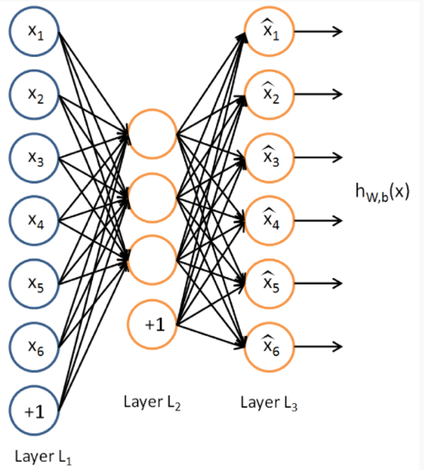

GAN works with optimization that minimizes a distance between the observed

empirical distribution and the generated distribution. 

Autoencodes applies backpropagation, by setting the target value same as input. GAN uses forward and back propagation, feedback from D goes to G to stimulate training.

1. **How is the distribution $p_{g}(x)$ learned by the generator compared to the real data distribution $p(x)$ when the discriminator cannot tell the difference between these two distributions? (15% of CW2)**

Generator found an estimate distribution that closely resembles real data distribution made from a set of samples and used by discriminator for analysis.

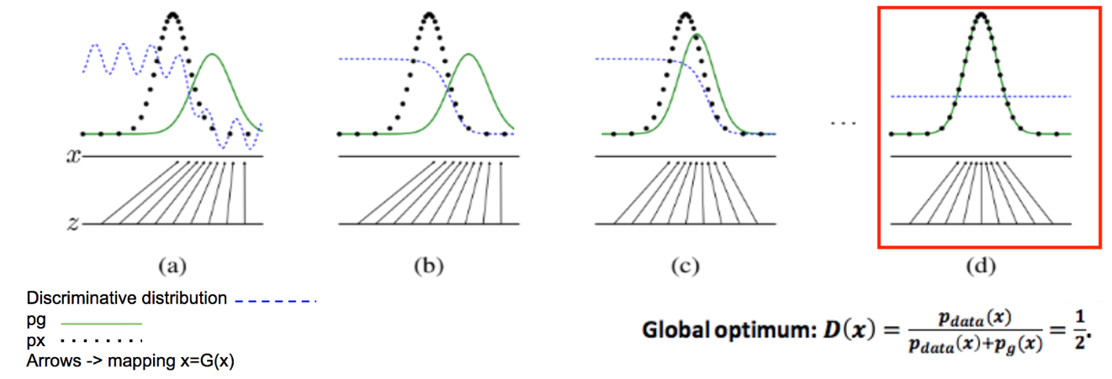

1. **Show the generated images at 10 epochs, 20 epochs,50 epochs,100 epochs by using the architecture required in Guidance. (15% of CW2)**

